Header

🧠 What Is a Header in Network Data Structures?
# Source: Chatgpt (GPT‑5 Mini) at [12/14/2025]
A header is a block of control information added to the beginning of a data unit (such as a packet, segment, frame, or message) at each layer of the network protocol stack. It tells the receiving system how to handle the data.

📦 Simple Definition:
# Source: Chatgpt (GPT‑5 Mini) at [12/14/2025]
A header is the leading portion of a network data unit that contains metadata like addresses, protocol types, sequence numbers, and more — enabling proper routing, delivery, and processing.

📚 Where Headers Are Used (By OSI Layer):
# Source: Chatgpt (GPT‑5 Mini) at [12/14/2025]
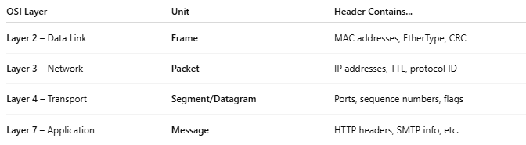

OSI Layer | Unit | Header Contains...
Layer 2 – Data Link | Frame | MAC addresses, EtherType, CRC
Layer 3 – Network | Packet | IP addresses, TTL, protocol ID
Layer 4 – Transport | Segment/Datagram | Ports, sequence numbers, flags
Layer 7 – Application | Message | HTTP headers, SMTP info, etc.

📄 Example: IP Packet Header (IPv4)
# Source: Chatgpt (GPT‑5 Mini) at [12/14/2025]
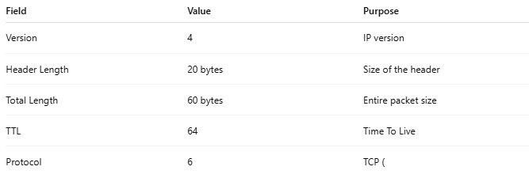

Field | Value | Purpose
Version | 4 | IP version
Header Length | 20 bytes | Size of the header
Total Length | 60 bytes | Entire packet size
TTL | 64 | Time To Live
Protocol | 6 | TCP (

🧱 Header – Visual Example
# Source: Chatgpt (GPT‑5 Mini) at [12/14/2025]
Certainly! Here's a 🧱 Visual Example of a Header in a network data structure — specifically from different OSI layers — to help you understand how headers look and what they include.

📦 Example: TCP/IP Data Encapsulation
# Source: Chatgpt (GPT‑5 Mini) at [12/14/2025]
Let’s break down a data packet as it passes through layers (Application → Transport → Network → Data Link).

▶ Final Packet (Ethernet Frame)
# Source: Chatgpt (GPT‑5 Mini) at [12/14/2025]
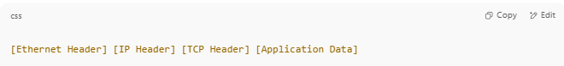
[Ethernet Header] [IP Header] [TCP Header] [Application Data]

🧠 1. Ethernet Header (Layer 2)
# Source: Chatgpt (GPT‑5 Mini) at [12/14/2025]
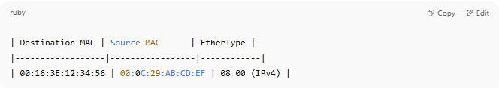
| Destination MAC | Source MAC | EtherType |
|------------------|-----------------|------------|
| 00:16:3E:12:34:56 | 00:0C:29:AB:CD:EF | 08 00 (IPv4) |

Hex representation:
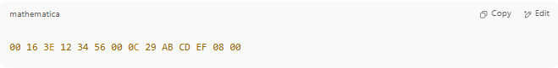
00 16 3E 12 34 56 00 0C 29 AB CD EF 08 00

🧠 2. IP Header (Layer 3)
# Source: Chatgpt (GPT‑5 Mini) at [12/14/2025]
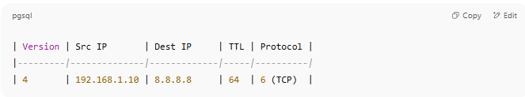
| Version | Src IP | Dest IP | TTL | Protocol |
|---------|--------------|-------------|-----|----------|
| 4 | 192.168.1.10 | 8.8.8.8 | 64 | 6 (TCP) |

Hex (partial):
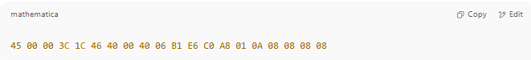
45 00 00 3C 1C 46 40 00 40 06 B1 E6 C0 A8 01 0A 08 08 08 08

🧠 3. TCP Header (Layer 4)
# Source: Chatgpt (GPT‑5 Mini) at [12/14/2025]
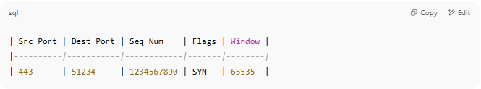
| Src Port | Dest Port | Seq Num | Flags | Window |
|----------|-----------|------------|-------|--------|
| 443 | 51234 | 1234567890 | SYN | 65535 |

Hex (partial):
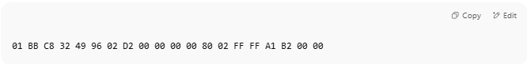
01 BB C8 32 49 96 02 D2 00 00 00 00 80 02 FF FF A1 B2 00 00

🧠 4. Application Data (Payload)
# Source: Chatgpt (GPT‑5 Mini) at [12/14/2025]
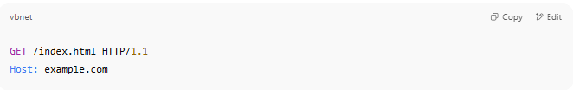
GET /index.html HTTP/1.1
Host: example.com

Hex (partial):
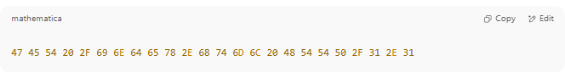
47 45 54 20 2F 69 6E 64 65 78 2E 68 74 6D 6C 20 48 54 54 50 2F 31 2E 31

✅ Summary: Header by Layer
# Source: Chatgpt (GPT‑5 Mini) at [12/14/2025]
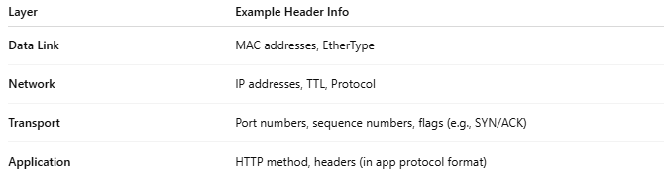
Layer | Example Header Info
Data Link | MAC addresses, EtherType
Network | IP addresses, TTL, Protocol
Transport | Port numbers, sequence numbers, flags (e.g., SYN/ACK)
Application | HTTP method, headers (in app protocol format)

